Assignment Sheet

Week 5

Q1

#include <iostream>

using namespace std;

class Complex

{

private:

int p,q;

public:

Complex()

{

cout<<"Enter real part of complex:";

cin>>p;

cout<<"Enter imaginary part of complex:";

cin>>q;

}

void operator +(Complex s)

{

cout<<"Sum: "<<p+s.p<<"+i"<<q+s.q;

}

};

int main()

{

cout<<"Complex 1:"<<endl;

Complex s1;

cout<<"Complex 2:"<<endl;

Complex s2;

s1+s2;

return 0;

}

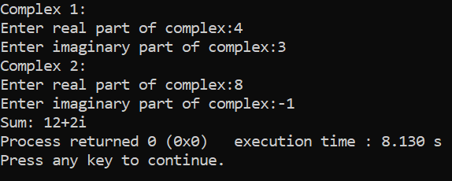

Q2

#include <iostream>

#include <string>

using namespace std;

class Box

{

int capacity;

public:

Box(){}

Box(double capacity){

this->capacity = capacity;

}

int operator < (Box &ob1)

{ if(ob1.capacity> capacity && ob1.capacity > capacity)

return(1);

else

return(0); }

};

int main(int argc, char const *argv[])

{

Box b1(10);

Box b2 = Box(14);

if(b1 < b2){

cout<<"Box 2 has large capacity.";

}

else{

cout<<"Box 1 has large capacity.";

}

return 0;

}

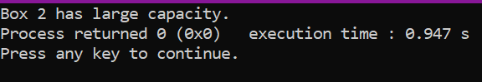

Q3

#include <iostream>

using namespace std;

class Check {

int i;

public:

Check(){

cout<<"Enter value of i"<<endl;

cin>>i; }

int operator ++() {

int a=i;

++a;

cout<<"++i = "<<a<<endl;

}

int operator ++(int) {

int b=i;

cout<<"i++ = "<<b<<endl;

b++;

}

};

int main()

{

Check obj;

++obj;

obj++;

return 0;

}

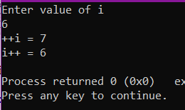

Q4

Hey Guys, I am a teacher

I am a Math Teacher

Name: Negan

College Name: Beginnersbook

Main Subject: Math

Q5

#include <iostream>

using namespace std;

class publication

{

string title;

float price;

public:

void getdata()

{

cout<<"title ";

cin>>title;

cout<<"price ";

cin>>price;

}

void putdata()

{

cout<<"Title "<<title<<endl;

cout<<"price "<<price<<endl;

}

};

class book:public publication

{

int count;

public:

void getdata()

{

publication::getdata();

cout<<"count ";

cin>>count;

}

void putdata()

{

publication::putdata();

cout<<"count "<<count<<endl;

}

};

class tape:public publication

{

float time;

public:

void getdata()

{

publication::getdata();

cout<<"time(in sec) ";

cin>>time;

}

void putdata()

{

publication::putdata();

cout<<"Time "<<time<<endl;

}

};

int main()

{

book b1;

tape t1;

cout<<"Enter details of book :"<<endl;

b1.getdata();

cout<<"Enter details of tape :"<<endl;

t1.getdata();

cout<<"Book : "<<endl;

b1.putdata();

cout<<"Tape : "<<endl;

t1.putdata();

}

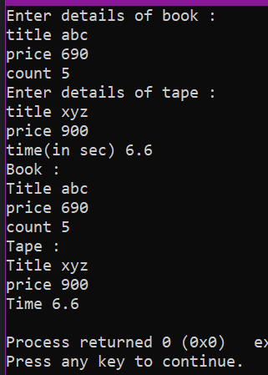}

Q6

#include <iostream>

using namespace std;

class publication

{

string title;

float price;

public:

void getdata()

{

cout<<"title ";

cin>>title;

cout<<"price ";

cin>>price;

}

void putdata()

{

cout<<"Title "<<title<<endl;

cout<<"price "<<price<<endl;

}

};

class book:public publication

{

int count;

public:

void getdata()

{

publication::getdata();

cout<<"count ";

cin>>count;

}

void putdata()

{

publication::putdata();

cout<<"count "<<count<<endl;

}

};

class tape:public publication

{

float time;

public:

void getdata()

{

publication::getdata();

cout<<"time(in sec) ";

cin>>time;

}

void putdata()

{

publication::putdata();

cout<<"Time "<<time<<endl;

}

};

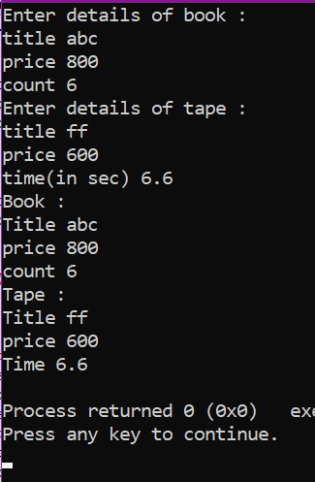int main()

{

book b1;

tape t1;

cout<<"Enter details of book :"<<endl;

b1.getdata();

cout<<"Enter details of tape :"<<endl;

t1.getdata();

cout<<"Book : "<<endl;

b1.putdata();

cout<<"Tape : "<<endl;

t1.putdata();

}

Q7 and Q8

#include<iostream>

#include<string.h>

using namespace std;

class account

{

public:

char name[30];

int acc_num,acc_type;

int balance;

int amount;

void getData()

{

cout<<"\nEnter the following details\nCustomer Name :";

cin>>name;

cout<<"\nAccount number :";

cin>>acc_num;

cout<<"\nAccount type\n1. Saving Account\n2.Current Account\n";

cin>>acc_type;

cout<<"\nAccount balance:";

cin>>balance;

}

void display()

{

cout<<"\nYour Account Balance :"<<balance;

}

void withdraw()

{

cout<<"\nEnter the amount you want to withdraw :";

cin>>amount;

if(amount>balance)

cout<<"\nInsuficient balance";

else

balance=balance-amount;

display();

}

};

class cur_acct:public account

{

public:

void panelty()

{

if(balance<200 && acc_type==2)

{

balance=balance-20;

display();

}

}

};

class sav_acct:public account

{

public:

void interest()

{

int t;

cout<<"\nEnter time interval in year:";

cin>>t;

balance=balance*(1+2*t);

display();

}

};

int main()

{

account ac;

ac.getData();

ac.display();

ac.withdraw();

}

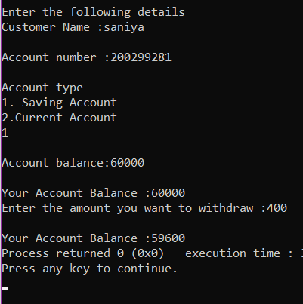

Q9

96